
To change the main voice mail greetings:

From within your office:
1. Press the V-Mail button.
2. When the system asks for your password press * # (pound) 0000
3. The system will ask for a password:
4. Enter 1 to edit prompts.
5. Enter the prompt number:
The OPEN greeting is: Prompt 1001
The CLOSED greeting is: Prompt 1002
The HOLIDAY greeting is: Prompt 1003
The WEATHER greeting is: Prompt 1004

6. Press: 1. To review current recording.
2. DO NOT USE.
3. To delete and re-record.
#. To save recording

7. Hang-Up

From outside your office:
1. Call the telephone number that is answered by the voice mail system
2. When you hear the main greeting press # (pound) 0000
3. The system will ask for a password: (Given by request)
4. Enter 1 to edit prompts.
5. Enter the prompt number:
The OPEN greeting is: Prompt 1001
The CLOSED greeting is: Prompt 1002
The HOLIDAY greeting is: Prompt 1003
The WEATHER greeting is: Prompt 1004

6. Press: 1. To review current recording.
2. DO NOT USE.
3. To delete and re-record.
#. To save recording

7. Hang-Up

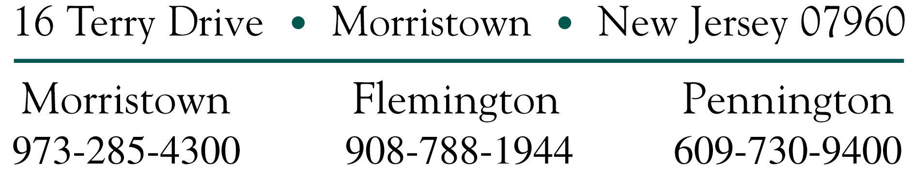

To change the voice mail mode:

From within your office:
1. Press the V-Mail button.
2. When the system asks for your password press * # 0000
3. The system will ask for a password:
4. Enter 3 to change the mode.
5. Enter 0 for all ports.
6. Enter the mode number:
0. Auto Mode (This will follow the Open/Closed setting on your phone)
1. Open
2. Closed
3. Holiday
4. Weather

7. Hang-up.

NOTE- You need to return the voice mail to the AUTO MODE when the office opens for normal business.

From outside your office:
1. Call your main telephone number.
2. When the system answers press # (pound) 0000
3. The system will ask for a password:
4. Enter 3 to change the mode.
5. Enter 0 for all ports.
6. Enter the mode number:
0. Auto Mode
1. Open
2. Closed
3. Holiday
4. Weather

7. Hang-up.

NOTE- You need to return the voice mail to the AUTO MODE when the office opens for normal business.

